2023 Charles Hicks Challenge Paddler Briefing

Thank you for entering and supporting the 2023 Charles Hicks Challenge.

If you haven’t had a chance to read the Race Rules please do take some time to read them beforehand. This note only covers additions and updates and should be read in conjunction with the rules.

The course
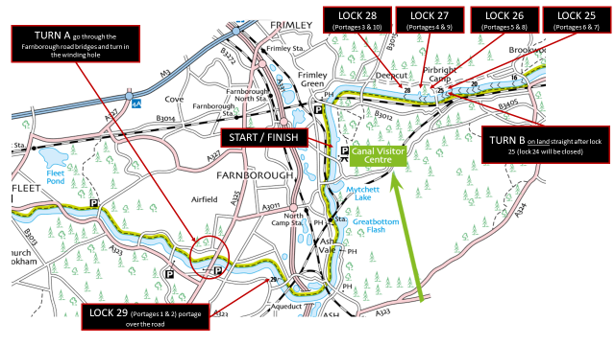
River right at all times while paddling.
The nature of the course dictates that boats will be travelling in both directions. Be courteous and patient at all times. Don’t let the red mist descend!
Overtake to the left of the slower paddler (i.e. towards the centre of the canal) and DO NOT impede the path of an oncoming paddler.
Fishermen. ALWAYS give a wide berth and avoid lines and floats. Be courteous at all times.
There is a risk of ice in certain areas at this time of year. If the ice is too thick, the event will be cancelled. For small accumulations, a trail blazer boat will be employed. Watch our Facebook Page and Website for weather news.

Portages

There will be a marshall at the road crossing. Please obey their instructions. Do NOT try and portage under the bridge; it is too narrow and you may damage your boat. The road can be very busy at times so please exercise extreme caution.
There will also be marshalls at Turns A and B. Again, please obey their instructions.
You MAY NOT run between locks/portages. Specifically, you must portage around each lock and each lock only.
Please be vigilant for other towpath users. They ALWAYS have the right of way over your portage.
Slower paddlers, please give way to faster paddlers at portages.
Boats will be portaging in both directions. Use the following protocol at portages:
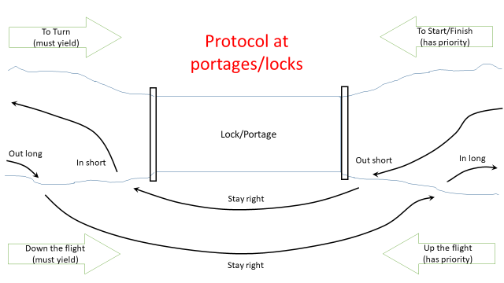

Crews coming up the flight of locks have priority over crews going down the flight of locks.
Going down? Out long – in long where possible.
Going up? Out short – in short where possible.
BE PATIENT AND COURTEOUS AT PORTAGES

Contact numbers:
If you need to retire or require other urgent assistance on the day, please contact race control:
- 07946 758754 ask for Bill Hansell

Remember: you are responsible for your own safety!

Don’t Forget to Bring Your…

BC Membership | Some means of showing your BC membership should be available to you, in case you are asked. | £5.00 for an event ticket if are not a BC member.
Buoyancy aid | Will be checked before starting. | Must be worn by all inexperienced crews and all paddlers in divisions 9 through 7.  Recommended for all other divisions 6 through 1 paddlers but not mandatory.
Spray deck | Not mandatory. | The water is calm so spray decks are not mandatory. There are also 10 portages. The use of spray decks is therefore at the individual’s choice.
Emergency Kit | Mandatory for all inexperienced crews. Will be checked at check-in.  Recommended for all other paddlers but not mandatory.  A good time to check your DW mandatory kit requirements. | The minimum inventory is as follows:  - sleeved thermal underwear to fit or complete tracksuit  - hat  - survival bag or foil blanket  - energy drink and bar of chocolate/energy bar  All in a waterproof container.  Carry a mobile phone in a waterproof bag if at all possible.
Boat Buoyancy | Will not be checked. | However: Competitors must ensure their boat has adequate buoyancy before starting.  Again, a good time to ensure you are DW compliant.
Appropriate Clothing | It is likely to be moderately cold on the day with a slight risk of rain/snow/sleet at this time of the year. | Wear appropriate clothing, in layers, including a base layer. Hats are highly desirable. Consider open palmed gloves and/or poggies.
Footwear | Is recommended. | The canal can be quite deep in places and where you can wade you may find glass or other sharp objects on the canal bottom; the mud can also be quite sticky making it difficult to move. Portages will be over a mixture of rough surfaces. You are advised to wear appropriate footwear.
Boat and paddles. | Will not be checked. | But do check all adjustments and that all nuts and bolts are tight. Check rudder in particular.
Payment | No cash or cheques on the day | Is strictly online when entering. No cash on the day please. We will have a card reader.

Parking
Is free onsite.
If we need to use parking facilitators, please follow their instructions.
There is an earth mound for boat preparation. Please use the mound as necessary then move your boat to the flat area by the fence so others can do their set-ups.

Facilities at the Canal Centre
The Canal Centre function room will serve as race control and for paddler’s food after the race.
Toilets are located at the canal centre also.
There are changing facilities adjacent to the BCCC main boat store. DO NOT leave possessions unattended in the changing rooms. Any and all losses are the paddler’s responsibility. Please be respectful of the changing facilities and leave them as you would wish to find them.
There is a café on site at the Canal Centre. Otherwise Potters is just next door or there is the Swan pub a couple of miles along the towpath towards Ash Vale (which has a beer garden overlooking the canal).
Costa coffee is available at Farnborough Gate (3 miles away by car).
M&S food is available at the nearby BP service station.
Support crews are reminded that this race is intended to be unsupported. This is not the event to practise DW levels of support for your crews. And, there is very limited parking along the course anyway. If you choose to support by bicycle, it will be muddy in places. A mountain bike is necessary. Please be considerate to all other towpath users.

Check in
Starts at 10am and ends at 11am
You must check in and collect your race number before you start.
The information you provided online will be printed for you to check and confirm. Additionally, we will require you to provide the following additional information as necessary:
- Relevant medical conditions
- Any special assistance needs
- Contact details for any Towpath support
- BC divisional ranking/level of experience
- Club
Race numbers will be allocated and you will receive a number board.
Please return your number board when you get your paddler’s food.

Turns
The turns will be marshalled. Follow their instructions at all times.
There will not be a buoy at turns.
Turns should be counter-clockwise.
You must turn either after you have passed the marshal or as directed by the marshal (if, for example, there’s a load of fishermen at the turn the marshal may direct you to turn earlier or later as required).
Support crews intending to cycle the route should make sure their bikes are road legal and bring helmets.
Motorised support is not allowed except for extrication of retired crews.

Results/Times
Will be published online after the event and informally on the day.
Each participant will receive a prise (when you hand your number board in).
There are no prizes for first, second, third, best dressed as a carrot etc.

Other Canal Users
Please be courteous and considerate to other canal and towpath users - strive to leave them with a good impression of our sport.

Safety
The canal is very rural and you can expect temperatures to be a degree or so lower than indicated by the weather forecast. Although the canal is generally sheltered there are a few places where a gust may catch you out. The water is, however, cold. It’s not quite at the level where choirs of brass monkeys will serenade your paddle, but not far off.
If you see a paddler in the water or on the bank then DO NOT pass unless you have a) offered to help and b) received an acknowledgement. Time credits will be awarded if you have to pause your race to help someone. Report and any sightings of retirements or capsize to a marshall.
In the event of capsize you should aim to swim/wade to the towpath side of the canal.

Swans
You will encounter a few swan families along the route. Some of the males are still somewhat aggressive so you are advised to be careful when passing. If you decide to take a portage round a family group please be aware that the towpath is a designated SSSNI (Site of Special Stinging Nettle Interest).

Child protection
If you have to stop to help a junior it is a good idea to ensure there are three of you present. Ask the next boat crew along to help and call race control as soon as you can and we will ask our event welfare officer to attend.

Medical Conditions
If you have any medical conditions that may impact your ability to race or the help we may be able to provide in the event you need to retire please advise Race Control before you start.

HAVE A GREAT CHARLES HICKS CHALLENGE!

