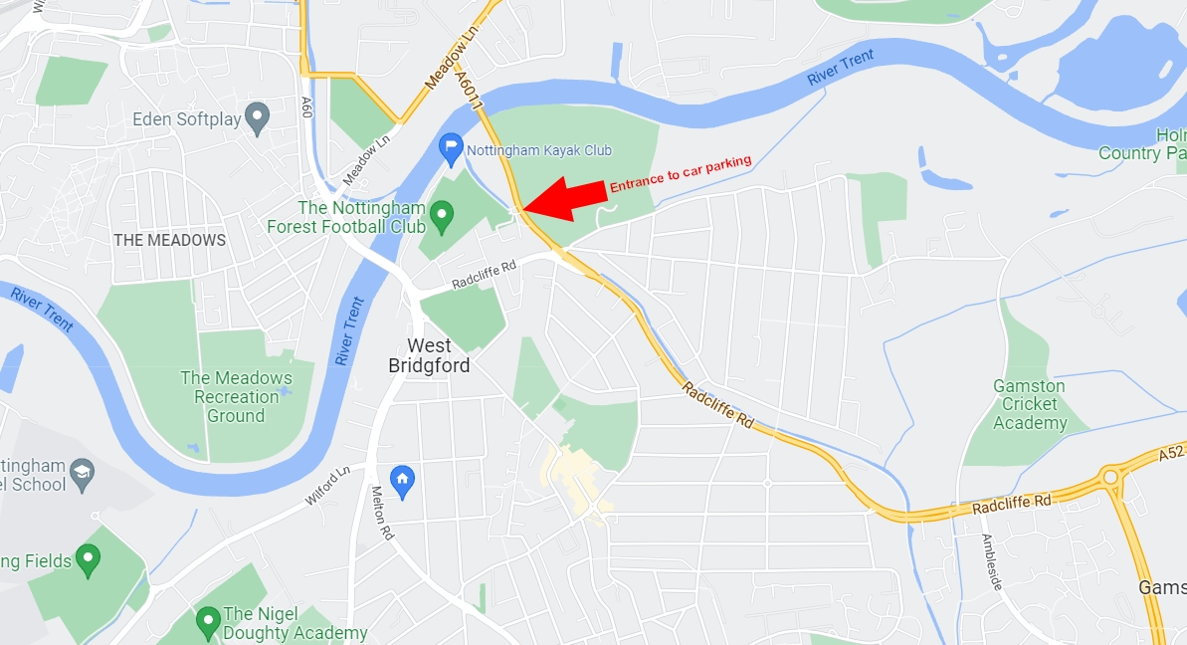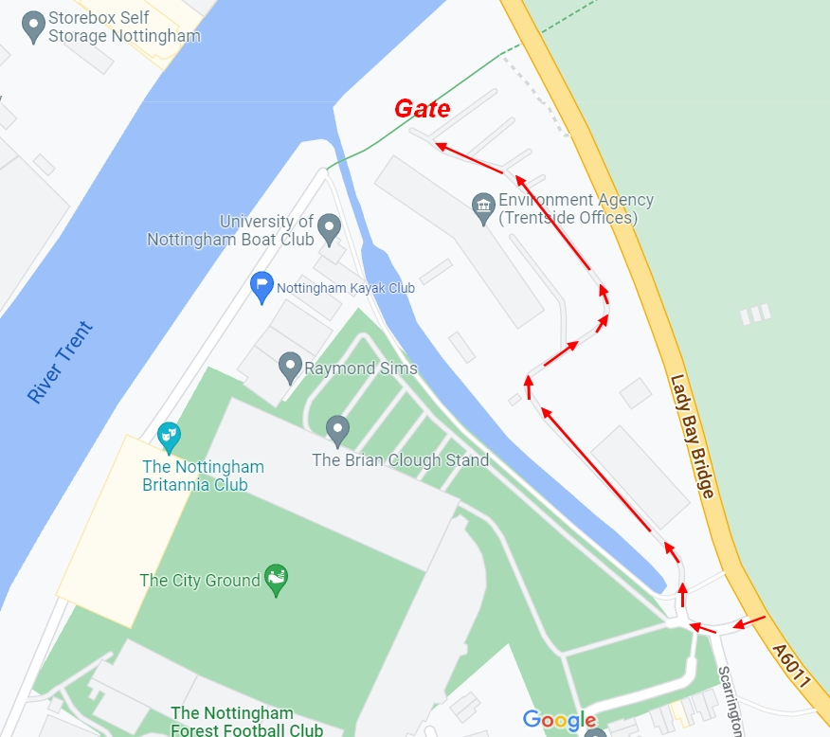

**Revised detail of parking – now in Environment Agency Car Park**

**Area Map**