Reading K1/C1 Assessment (SC & LC)
18-June-2022

Venue: The Prom
Thameside Promenade, Reading, RG1 8DP
South bank of the Thames, upstream of Caversham Bridge. Follow signs to Reading town centre, then signs for Caversham.
Parking on the site: £3 per car
Please note: No parking is available at Reading Canoe Club.
Catering / Facilities: there will be limited facilities available as this is being run on the Prom. Toilets, fresh water tap and paddler food will be available. There is a café behind the rowing club on the Prom that will be open.

Times
Time | Event | Comment
8:30 | Parking opens | £3 parking fee per car
9:00 | Check in opens | Team leader where possible
9:30 | Briefing for SC & LC
10:00 | SMK1 & U23KM1 SC  SWK1, U23WK1 & SMC1 SC
10:30 | JMK1  JWK1, SWC1 & JWC1 SC
12:30 | SMK1 & U23MK1 LC  JMK1 LC  SWK1, U23WK1 & SMC1 LC  JWK1, SWC1 & JWC1 LC
15:30 | Site closed

Entry Fees
Pre-entries: £15 (pre-paid)
Late entry (on the day): £20 (cash on the day)
Please enter via MRC entry Portal (Tableized)
Entries to be received Wednesday 15th by 22:00
Late entries are accepted on the day at an additional £5 per seat
Where possible, team leaders to check in, pay and make late changes.
Entrants must have a valid British Canoeing membership card to show at check-in if the latest ranking list does not show a valid expiry date. No card no race.
British Canoeing day tickets (£5.00) are available for divisions 7 to 9 only.

Selection Events:
Class / Start | Short Course | Long Course
SMK1 & U23MK1 | 3.6km Straight Final  3 x laps, two portages | 24km  4 laps, four portages
JMK1  SWK1, U23WK1 & SMC1 |  | 18km  3 laps, three portages
JKW1 & SWC1 & JMC1 |  | 12km  2 laps, two portages
- Juniors must be aged under 18 on 1st January of the race year.

The Courses:
Short Course:
3.6km, 3 laps, 2 portages. clockwise course.
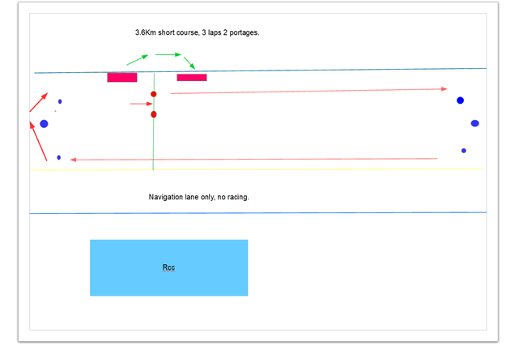
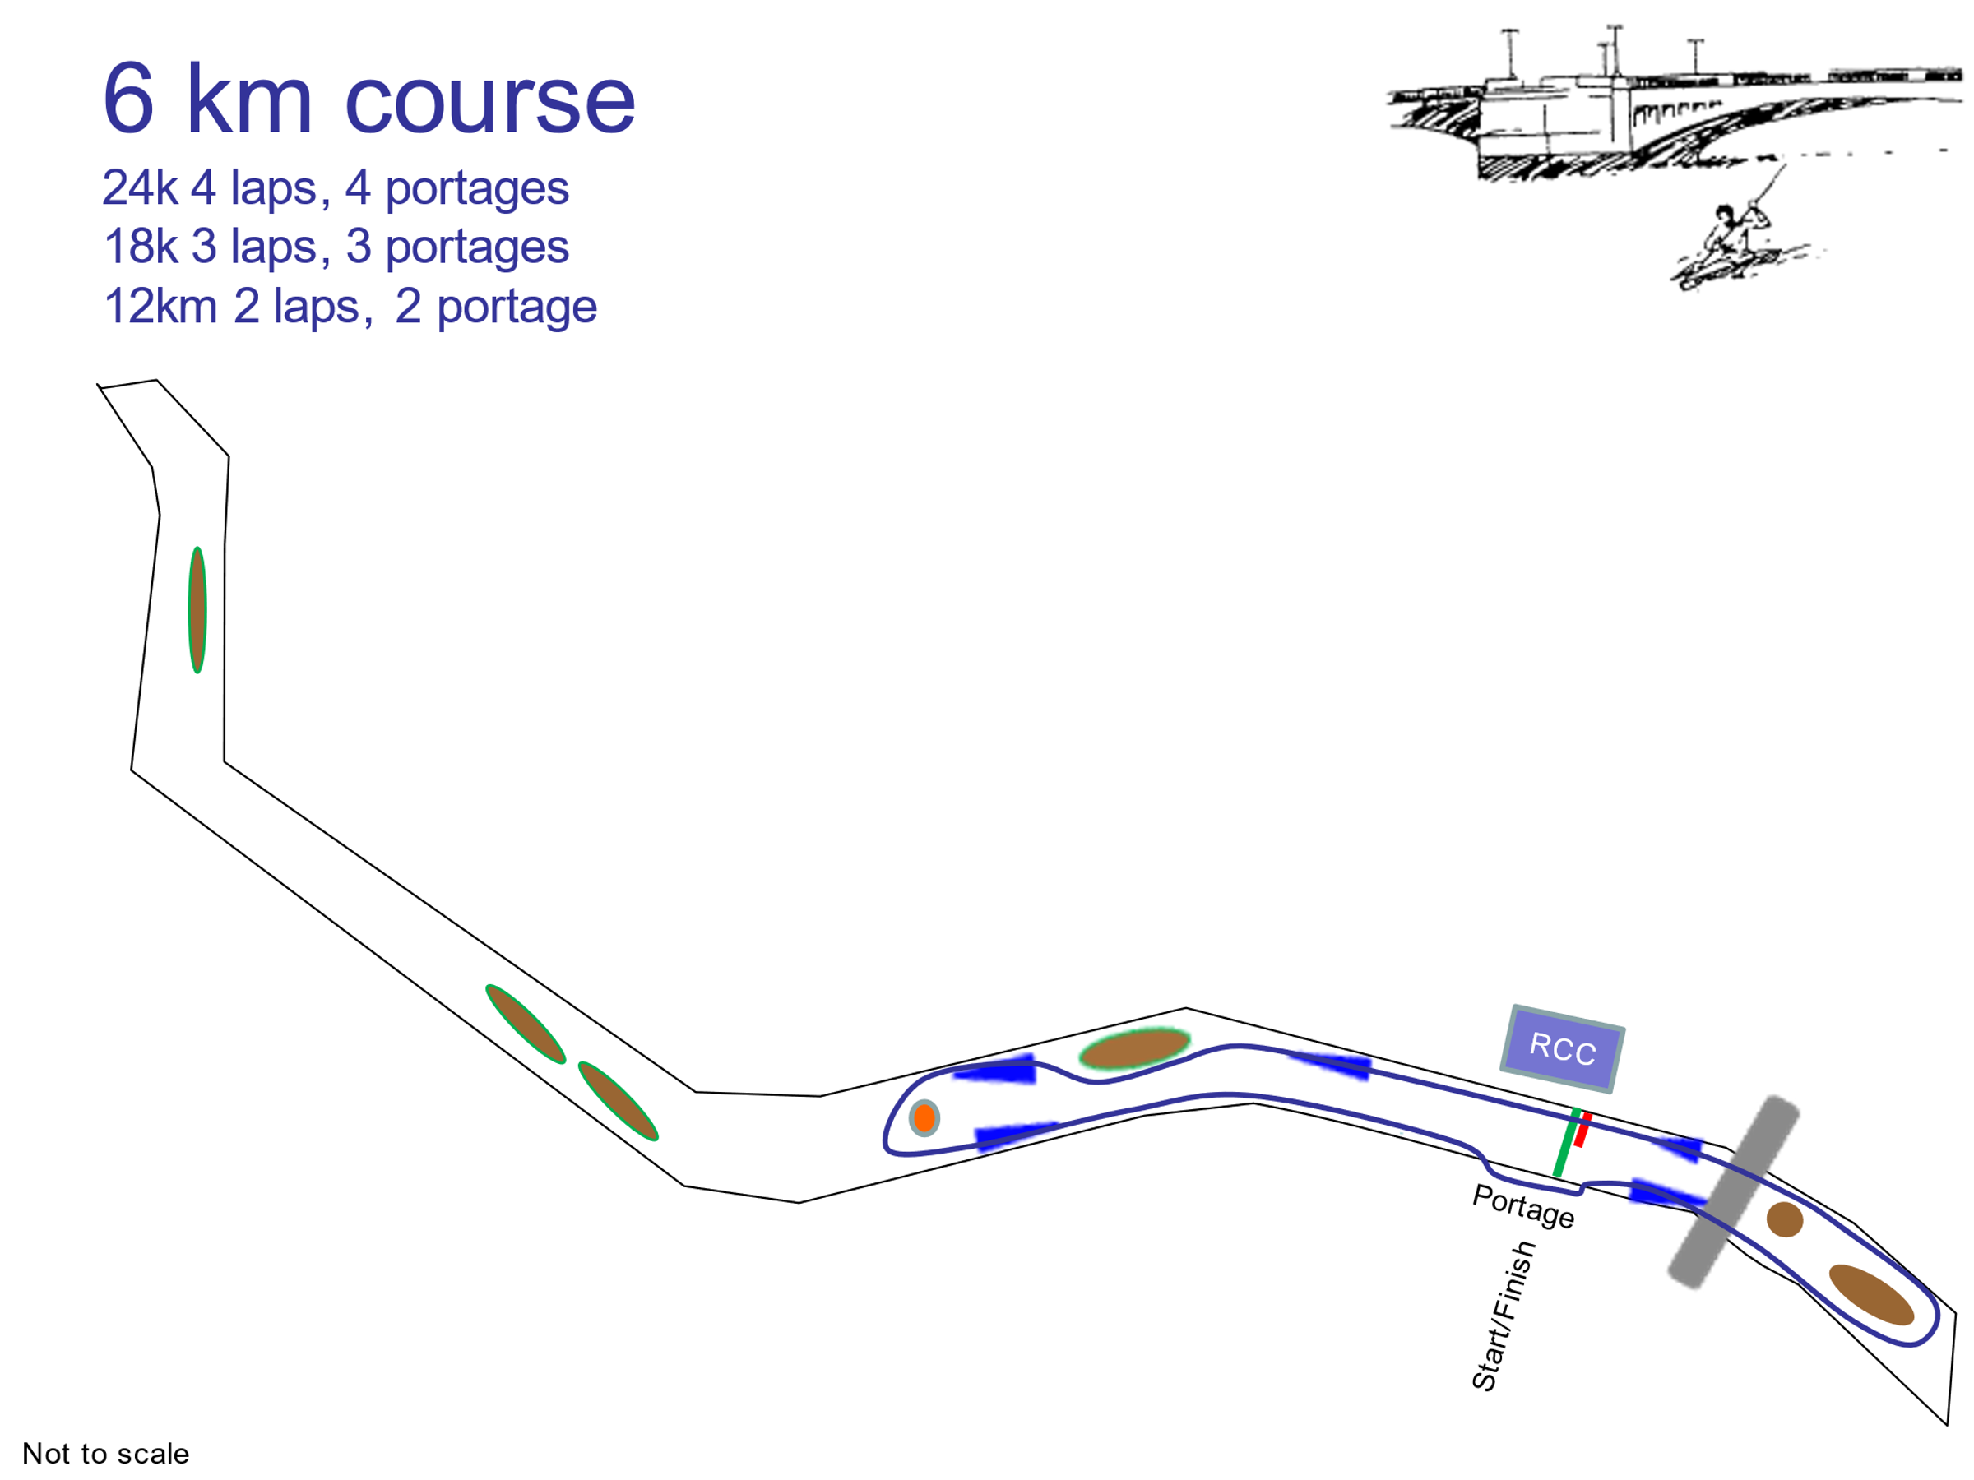
Long Course:

Notes to Competitors
- The race will be run in accordance with the assessment rules in the Canoe Racing Handbook.
- Club racing vests must be worn (or white if racing as independent).
- No wash hanging outside of the boats on your start line
- This assessment event will be used as part of the selection for the European Championships and the Sanabria K4. You must race in the class that you are seeking selection for.
- This assessment event may also be used for the selection of the World Championships.
- Team leaders should decide if paddlers under 16 years of age in higher divisions should wear a buoyancy aid.
- The race organiser has the final say on who has to wear a buoyancy aid.
- Team Leaders are responsible for ensuring that paddlers are properly equipped having taken into account the paddler’s health, fitness, capability, the course, the prevailing conditions and other risks associated with this race.
- Vertical number plates will be provided, £5:00 charge for lost numbers.
- It is likely that paddlers will encounter other craft on the river. Rules of the river must be observed when racing – keep right.
- All pre-entries must be received by 22:00 noon Wednesday 15th. After this date, a late entry fee will be levied.
- British Canoeing numbers must be with entry.
- Competitors must render their boats sufficiently buoyant to remain afloat and to support the crew in rough water in the event of capsize. No boat will be deemed to be sufficiently buoyant purely as a result of its construction (e.g. vac bagged/ sandwich or other construction) to fulfil this requirement, additional buoyancy will be required in the form of foam, airbags and/or sealed bulkheads.
- During the course of the competition any items discarded by a competitor anywhere other than in a proper bin, must be recovered by the athlete, their support crew or coach immediately. It is the athlete’s responsibility to ensure that this has happened. An event official witnessing non-compliance with this rule shall report the infringement to the race organiser and the offending competitor will be disqualified from the competition.
- Reading Canoe Club and its nominated officials cannot be held responsible for any loss of life, injury or damage to equipment however caused.
- You agree that we may publish your Personal Information as part of the results of the Event and may pass such information to the governing body or any affiliated organisation for the purpose of insurance, licences or for publishing results either for the event alone or combined with or compared to other events. Results may include (but not be limited to) name, any club affiliation, race times, occupation and age category.

